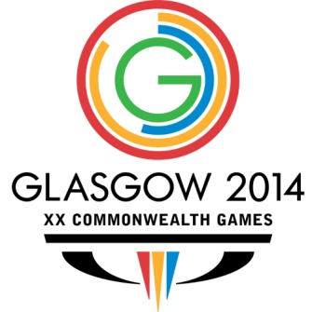

**Commonwealth Games: Singapore win Bronze in Badminton Mixed Team event**

July 28, 2014

**Glasgow** ­­– Singapore secured the Bronze Medal in the Mixed Teams Badminton at the Commonwealth Games in Glasgow today (July 28) with a 3-2 victory over India.

In the final rubber, the Women’s Doubles, Shinta Mulia Sari and Yao Lei beat Indian pair Jwala Gutta and Ashwini Ponnappa 29-27 in the second game to win the match. The tight final rubber lasted 56 minutes, taking a seventh match point.

Danny Chrisnanta and Vanessa Neo got the Singapore Team off to a strong start when they beat RV Gurusaidutt and Ponnappa 21-19, 21-29 in the Mixed Doubles.

India’s Kashyap Parupalli beat Huang Chao 21-15, 22-20 in the Men’s Singles before Chrisnanta and Chayut Triyachart restored Singapore’s lead with a 21-12, 21-16 win over Akshay Dewalkar and Pranav Chopra in the Men’s Doubles.

The tie was pulled level once again when PV Sindhu overcame Liang Xiaoyu with a 24-22, 21-13 score line to make it 2-2 overall.

But the Singapore Women’s Doubles Team held their nerve in the final rubber to win the Bronze.

--------------------------